Superstore Sales Analysis using Tableau
Welcome to the Superstore Sales Analysis! This project offers an in-depth analysis of sales data from a fictional superstore, using Tableau to uncover insights into sales performance, customer behavior, and market trends.
📖 Introduction
This project is designed to help businesses understand their sales data better, make informed decisions, and optimize their strategies. By visualizing key metrics and trends, this analysis aims to provide actionable insights into how different factors impact sales performance.
✨ Features
- Interactive Dashboards: Visualize sales data across various dimensions such as region, category, and time.
- Sales Performance Analysis: Identify top-performing products, regions, and sales periods.
📊 Dataset Information
The analysis is based on the Sample Superstore Dataset provided. The dataset includes information on sales, profits and more.
Important:
- Dataset Extraction: Ensure that the Superstore sales dataset.csv file is properly located in the same directory as your Tableau workbook for it to fetch data correctly.
🛠️ Place the Dataset:
  - Ensure that Superstore dataset.csv is in the same directory as the Tableau workbook.
- Open the Tableau Workbook:
  - Double-click on Superstore sales.twb to open the Tableau workbook.
  - Tableau will automatically connect to the dataset and load the visualizations.
🚀 Usage
- Explore Dashboards: Open the Tableau workbook and navigate through the interactive dashboards to explore sales data.
- Filter and Drill Down: Use filters to drill down into specific regions, categories, or time periods for a more detailed analysis.
- Export Visuals: Tableau allows you to export the visualizations in various formats (PDF, Image, etc.) for presentations or reports.

📈 Results and Visuals
Here are some key insights and visualizations generated by the analysis:
- Superstore Sales Review
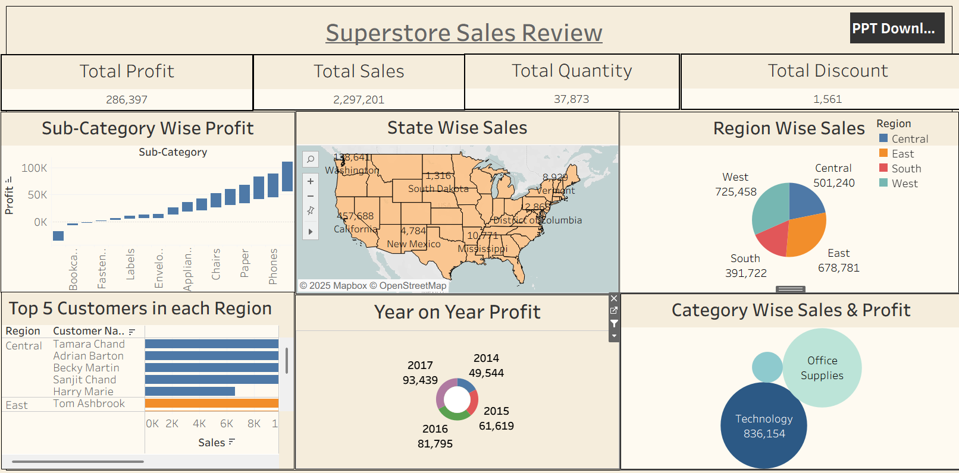
Superstore Sales Analysis
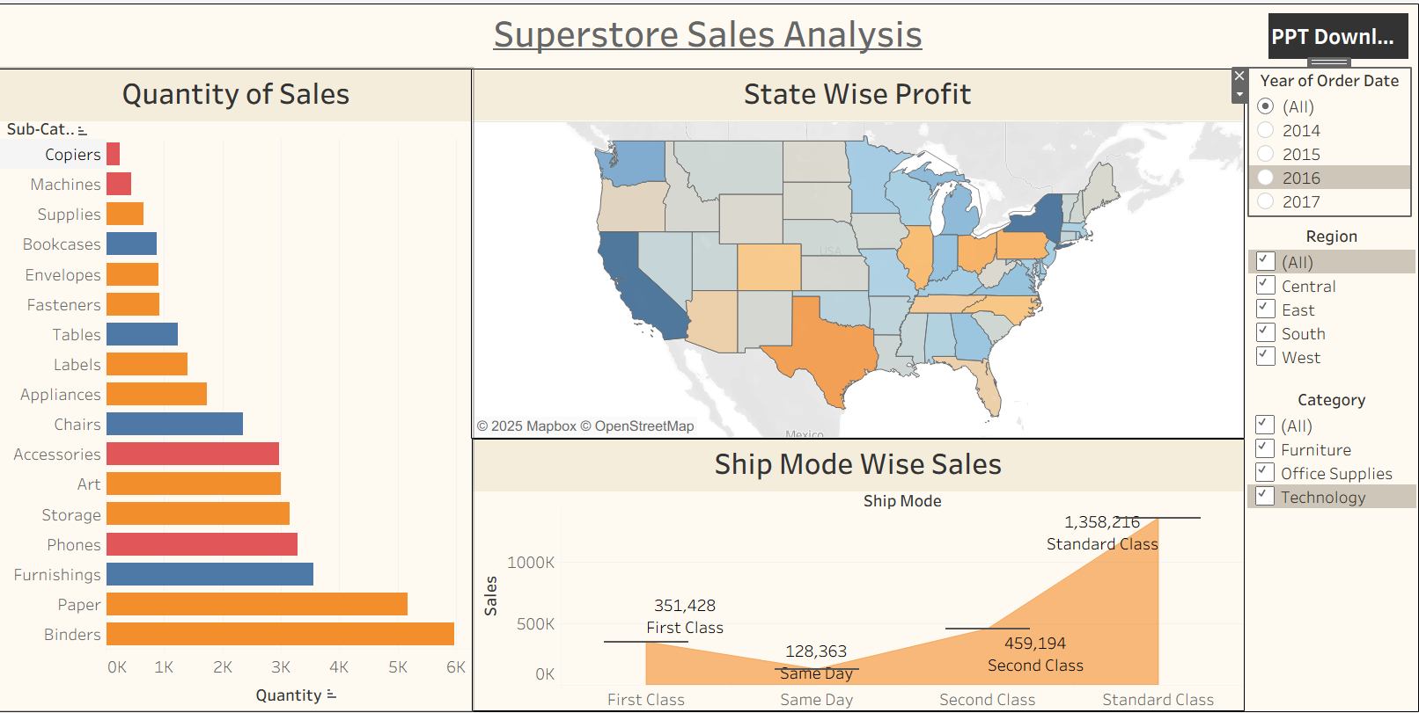
Conclusion
Tableau can be used as a powerful BI tool to understand, transform and project data in multiple ways to improve and enhance and contribute to the overall success of the organisation.
Shortcut to the Tableau Superstore Dashboard:

